**VIETNAM NATIONAL UNIVERSITY HO CHI MINH CTIY**

**UNIVERSITY OF INFORMATION TECHNOLOGY**

**ADVANCED PROGRAM IN INFORMATION SYSTEMS**

**TRAN THANH HUY – TRUONG LE BAO LONG**

**SIMILAR DOCUMENT RETRIEVAL**

**USING GRAPH MODEL**

**BACHELOR OF ENGINEERING IN INFORMATION SYSTEMS**

**HO CHI MINH CITY, 2016**

**VIETNAM NATIONAL UNIVERSITY HO CHI MINH CTIY**

**UNIVERSITY OF INFORMATION TECHNOLOGY**

**ADVANCED PROGRAM IN INFORMATION SYSTEMS**

**TRAN THANH HUY 12520611**

**TRUONG LE BAO LONG 12520982**

**SIMILAR DOCUMENT RETRIEVAL**

**USING GRAPH MODEL**

**BACHELOR OF ENGINEERING IN INFORMATION SYSTEMS**

**THESIS ADVISORS**

**ASSOC. PROF. DR. DO PHUC**

**HO CHI MINH CITY, 2016**

# ASSESSMENT

………………………………………………………………………………………………………………………………………………………………………………………………………………………………………………………………………………………………………………………………………………………………………………………………………………………………………………………………………………………………………………………………………………………………………………………………………………………………………………………………………………………………………………………………………………………………………………………………………………………………………………………………………………………………………………………………………………………………………………………………………………………………………………………………………………………………………………………………………………………………………………………………………………………………………………………………………………………………………………………………………………………………………………………………………………………………………………………………………………………………………………………………………………………………………………………………………………………………………………………………………………………………………………………………………………………………………………………………………………………………………………………………………………………………………………………………………………………………………………………………………………………………………………………………………………………………………………………………………………………………………………………………………………………………………………………………………………………………………………………………………………………………………………………………………………………………………………………………………………………………………………………………………………………………………………………………………………………………………………………………………………………………………………………………………………………………………………………………………………………………………………………………………………………………………………………………………………………………………………………………………………………………………………………………………………………………………………………………………………………………………………………………………………………………………………………………………………………………

# ASSESSMENT COMMITEE

………………………………………………………………………………………………………………………………………………………………………………………………………………………………………………………………………………………………………………………………………………………………………………………………………………………………………………………………………………………………………………………………………………………………………………………………………………………………………………………………………………………………………………………………………………………………………………………………………………………………………………………………………………………………………………………………………………………………………………………………………………………………………………………………………………………………………………………………………………………………………………………………………………………………………………………………………………………………………………………………………………………………………………………………………………………………………………………………………………………………………………………………………………………………………………………………………………………………………………………………………………………………………………………………………………………………………………………………………………………………………………………………………………………………………………………………………………………………………………………………………………………………………………………………………………………………………………………………………………………………………………………………………………………………………………………………………………………………………………………………………………………………………………………………………………………………………………………………………………………………………………………………………………………………………………………………………………………………………………………………………………………………………………………………………………………………………………………………………………………………………………………………………………………………………………………………………………………………………………………………………………………………………………………………………………………………………………………………………………………………………………………………………………………………………………………………………………………………

ACKNOWLEDGEMENTS

We would like to express our gratitude to advisors, Associate Professor PhD. Do Phuc who suggest, instruct and encourage us during the time we do thesis.

We would like to express my thankful to Mr. Nguyen Ho Duy Tri – an elder brother from Information System’s Laboratory in University of Information Technology for his tools and advices in researching Scrapy framework.

We would like to express my thankful to Mr. Le Hong Phuong – a researcher at FPT Research Institute for his Vitk tool, which is a Vietnamese text processing toolkit which can process very large text data.

We appreciate the charity of JetBrain, Apache corporation. They have supply the all free professional, utimate software licenses to students that help us a lot of things not only in the thesis, but also in our study in university. GitHub also recommends free hosting to us.

We would like to express my thankful to the staffs in Faculty of Information Systems of University of Information Technology who emit the passion to us as well as equipt us enough basic kwnoledge in the recent year.

We should say thank you to our family for providing us the best conditions to study in Advanced Education Program and finish this graduation thesis.

Although we have try effort to finish this thesis in suitable range and our best abilities; certainly it can not avoid the disadvantages and errors, we respecfully wait for sympathy and feedbacks of our Lecturers and friends. We sincerely say thank you.

Winter 2016,

Tran Thanh Huy – Truong Le Bao Long – Student of CTTT2012

LIST OF FIGURES

Figure 1-1 Picture of the movie "Who Framed Roger Rabbit?" 2

Figure 1-2 Google Glass - the future of AR 2

Figure 1-3 Top 5 Augmented Reality SDK's 3

Figure 1-4 The number of mobile devices and mobile operating systems 4

Figure 1-5 The graph show the number of print almost decreased in a lot of region, especially Western Europe and North America 6

LIST OF TABLES

Table 4-1 Fields in request body to create, update target. 54

Table 4-2 Return result of creation new target API .55

ABSTRACT

Why we need this product, what is this product

The system contains x modules:

Chapter 1

**Introduction**

*✍ The content of Chapter 1 introduces about………………….. By the end of this chapter, we summarize the primary content of each chapters in the thesis.*

1.1 Introduction

### 1.1.1. *GraphX*

1.1.2. *GraphY*

## 1.2 The motivation to do the topic

### 1.2.1. *A*

1.2.2. *B*

### 1.2.3. *C*

### 1.2.4. *Topic idea*

## 1.3. Objective

## 1.4. Content of topic

Thesis consists of X chapters:

**Chapter 1**:

**Chapter 2**:

**Chapter 3**:

**Chapter 4**:

**Chapter 5**:

**Chapter 6**: Summary, present the achieved results and the development of dissertation.

Chapter 2

Overview

*✍ Chapter 2 presents an overview augmented reality. Next is an introduction about Vuforia framework that group applies in the system.*

2.1. Augmented reality

2.1.1. *Augmented reality*

Augmented reality is the image processing from the surrounding environment in real world to determine the object and provide augmented information for founded objects and equipment. The application is programmed, built by integration to handle information received through the camera on the mobile device. The camera of mobile devices recognize and analyze the founded object (probably shaped object, photo or text and usually a range of bar codes in black and white color) which help the programmers to determine ways to add augmented information (text, pictures photos, audio or video ...) for the object and display to the users by the following ways:

Determine position, angles of found objects (planar data) than the camera's devices to draw information on the right marked spatial 3-D position. Or draw the 3D object.

Show augmented information about objects on users’ devices and additional features that users can interact with service providers.

The common point of the two methods is that the user can interact directly to augmented information. Augmented information are met in real time. AR only beginning to meet the needs of military and industry. When applying somewhere outside laboratory, AR become popular demand in social life.

Augmented reality appeared soon in the 1950s:

* 1957-1962: Morton Heilig - a cinematographer has created and been patented the invention of a device called Sensorama simulator providing pictures, sound, vibration, and scent.
* 1975: Myron Krueger created Video Place that allows users to interact with virtual objects for the first time in the world.

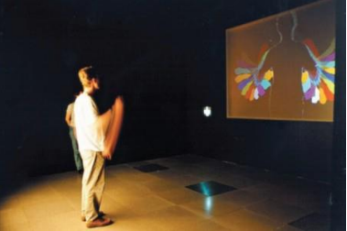

Figure 2-1 Myron Krueger interacted with video place.

* 1980: Steve Mann was the one who created the first wearable computer in the world - is a vision system computer with text and graphics overlaid on the actual image.

The system was further developed until 1990, the term "augmented reality" is officially used and who coined the term is a researcher of Boeing - Tom Caudell. Then, this technology is developing rapidly.

One typical application may include is the use of CAD (Computer Aided Design) to simulate the assembly of an aircraft, military, health care ... This technology is also used widely in the fields of advertisement, marketing.

In fact, this technology has proven to be very useful in today's life. When tied to place determination technology, some applications are built to help display to users of a grocery store, clothing store or shopping to identify traffic stations, the nearest visited destination...

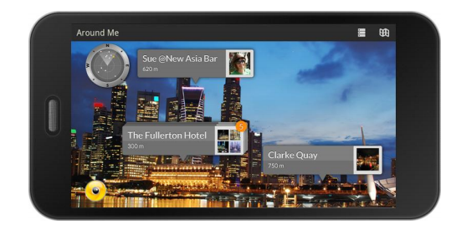

(A) The application Wikitude allows to search recent services around you. 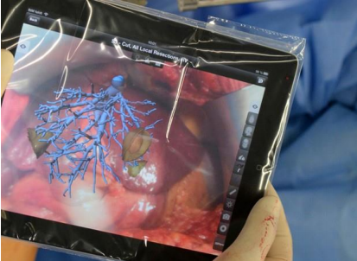

(B) The liver surgeon technological devices using AR.

Figure 2-2 the application uses the reality enhancement.

**(Source:** [**http://www.wikitude.com/app/how-to-use-wikitude/**](http://www.wikitude.com/app/how-to-use-wikitude/) **,** [**http://www.engadget.com/2013/08/22/fraunhofer-ipad-app-guides-liver-surgery/**](http://www.engadget.com/2013/08/22/fraunhofer-ipad-app-guides-liver-surgery/)**,** [**http://timesofindia.indiatimes.com/tech/slideshow/googleglass/Translate/itslideshow/18609226.cms**](http://timesofindia.indiatimes.com/tech/slideshow/googleglass/Translate/itslideshow/18609226.cms) **)**

In the medical field, this technology can give the surgeon the information which cannot be seen as: heart rate, blood pressure, the anatomical patient ... AR can be used to help doctors to look inside in a patient’s body by providing an X-ray image.

The most recent is the born of Google Glass devices announced by Google in 2013 with the notable feature:

* Navigation system on this device informs you exactly what you need to turn in street corner, displays a map surrounding area via Google Maps.
* Foreign language translation directly on the screen of Google Glass.
* Search for information of the products you see in front of your eyes then displays directly onto the device.

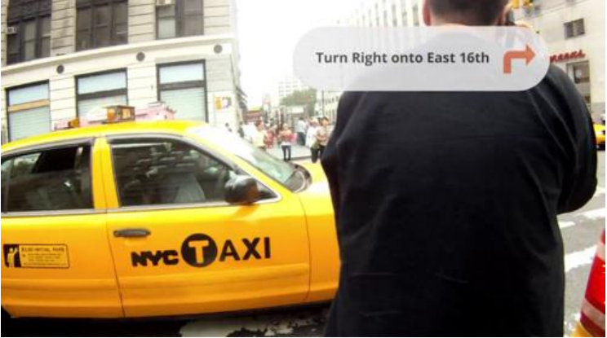

Figure 2-3 Google Glass path guide.

2.1.2. *Augmented reality applications in advertising*

Based on the providing information, the goal is to attract a large number of customers and minimize the current advertising restrictions as we can. The application of *augmented reality* technologies in advertising is one of modern options and highly appreciated.

Today, there are many enterprise applying this technology on the mobile devices to promote his company's products to the public. This provides a pretty good solution for bringing their image or helping the user to interact directly to the products.

From May 1/2011, REAL Group (France) real estate company provides free REAL me application on iPhone, iPad and Android phones that help users to buy or rent houses, apartments at the desired location. When the lens phone towards certain buildings belonging REAL Group, users can REAL me get information about the apartments they are targeting, superimposed images obtained by tube glasses.

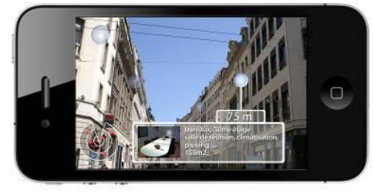 (a) REAL me app supplies information about department in France).

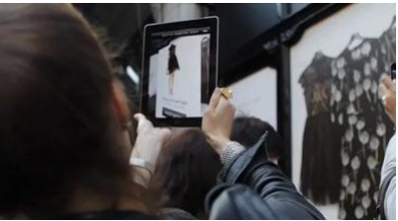

(b) The user views Apartments of Net-A-Porter.

Figure 2-4 the application software enhanced reality in advertising.

(Source: <http://echip.com.vn/thuc-tai-tang-cuong-a20130314160058393-c1107.html> )

9/2011, Net-A-Porter company decorated the entire store's clothing Alone in the big city like Paris, New York, London, Munich Photos by images in the collection of Karl Lagerfeld. Passersby are instructed how to download an application of company here. Users simply open the application and scanned image of the product through the device's camera. Immediately, the message about product information is displayed to the user view: specs, video demo clothing test samples, prices ... besides that users can select to how purchases and how to do online payment on the application.

Or as an advertising campaign of Volkswagen company in Canada. In 9/2011, car producers have urged people to download application VWJuicedUp to device. When the application has been installed, users simply use their mobile devices installed applications at the marked point on advertising board given by car producers. At this time, on the device - viewers are treated to a performance of the car reflected on advertising board that users towards. The car runs from advertising board and performances. [8]

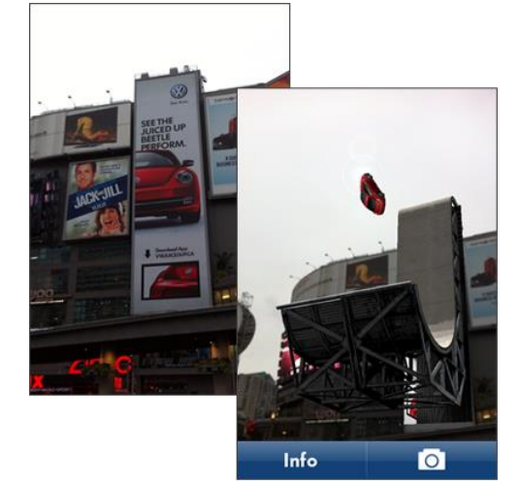

Figure 2-5 Performance on the device of the Volkswagen car.

(Source: <http://randymatheson.com/?p=668>)

How to apply *augmented reality* technology to advertisement to bring benefits for business: the interests of users, low cost, high popularity, convenience (direct purchases)...

It is sure to conclude that the number of people using mobile devices is increasing. By this reason, the common level using applications of third parties is proportional. When the application is downloaded, the scan an object, image, or text which provides plenty of needed information to them, promote their curiosity. As long as content augmented information of provider are attractiveness, interesting, creative and good interaction and meanwhile the increase number of clients using *augmented reality* applications are great turning point for the advertisement industry and services.

2.2. Overview about Vuforia

2.2.1. *Introduction*

Vuforia is a framework supporting augmented application of Qualcomn research center. Today, Vuforia supports Android, iOS and Unity 3D platforms. Vuforia supplies a lot of features supporting developers in creation augmented application running in many devices which does not require good knowledge in the aspect.

Vuforia is awarded Auggie for the best framework supporting augmented reality at Augmented World Expo 2013. By the donation of many large corporation as Audi, Viking, Lowe’s, Moosejaw, Sesame Street, Johnson… with the large society with more than ***60,000 developers*** in ***130 countries*** and more than ***4,500 applications*** (according to <https://www.vuforia.com/>), Vuforia is one of the best choices to build augmented reality application.

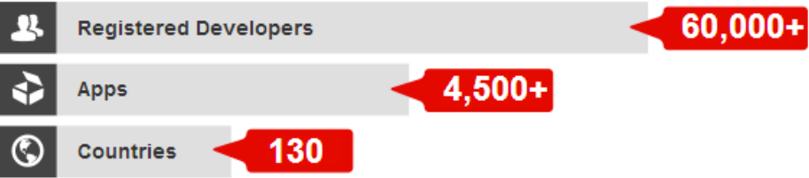

Figure 2-6 The development of Vuforia system

(Source: <https://www.vuforia.com/>)

Vuforia use computer vision technology to recognize and track image targets and 3D objects, such as box in real time with high quality even though hide condition and lack of light. From the recognized images, developers can present virtual objects as 3D model, augmented image in mobile screen. Targets are tracked in real time in order to match the vision angle of viewers and vision angle targets. It must satisfy the condition that virtual objects are part of real world.

By many features, Vuforia gives a hand in creation high quality application being able to interact with 3D images in real world giving customers a lot of new experiences in mobile devices.

**2.2.1. *Features***

Supported features in Vuforia:

* Recognize target by local data in devices or data in Cloud Recognition server with the number of suitable stored targets equal 1,000,000. Moreover, users can self-defined (user-defined) when application runs (run-time).
* Tracking one or multiple targets whenever users move devices around Image Target.
* Recognize 5 targets at the same time in hide condition and lack of light.
* Optimize to assure the high quality of graphical image in target.
* Vuforia supplies API (Application Programming Interfaces) written by C++, Java, Object-C, and .NET (through the extension of Unity game engine). By this way, SDK of Vuforia support in development in native code in both Android and iOS platform as well as make porting from Unity easily. Therefore, AR application using Vuforia is compatible in many mobile devices such as: iPhone, iPad, Android phone and tablet.

2.2.2. *Foundation structure of Vuforia*

Figure 2-7 Overview about process of development application by Vuforia framework supplies a general view how to build application with Vuforia. The platform includes Vuforia Engine, Target Management System stored in information data of Target Manager, and Cloud Target Database.

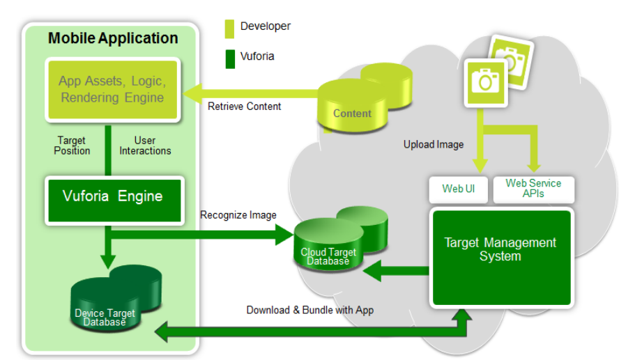

Figure 2-7 Overview about the process of development application by Vuforia framework

**(Source**:***https://developer.vuforia.com/sites/default/files/dev_guide_images/getting_started_SDK_devguide/Vuforia_Components_SDKsection.PNG )***

The process of development Vuforia application contains:

* Developers upload images of targets that they want to track to Target Management System.
* Them, developers use libraries supplied by Vuforia Engine as “share object – libQCAR.so” in Android or “static library – libQCAR.a” in iOS).
* Vuforia applications access to relative resources of tracking targets in two ways:

a. Access databases of targets from Cloud Target Database through web service.

b. Download databases of targets into devices and package with application.

2.2.3. *Fundamental knowledge about Vuforia SDK*

AR application developed by Vuforia SDK comprises following components (Figure 2.8 Model of AR application developed by Vuforia SDK):

* Camera: components in camera assure that each view is saved and passed to Tracker as efficient as possible. Developers can just start Camera and stop Camera. View automatically transfer to dependent device to format image and its size.
* Image Converter: Convert image format from camera format (YUV12) to suitable format of OpenGL ES to build image (RGB65) and do internal tracking. The convert also contain down sampling image in order to make image of camera in different resolution in camera change stack.
* Tracker: tracking components contain vision algorithm to recognize and track target in real world in camera. Based on image in camera, algorithms find and recognize targets or new marker and review virtual button. Results are store in state object used by Video Background Renderer and can be accessed from application code. Tracker can download multiple databases at the same time and active them.
* Video Background Renderer: display images from camera stored in object state. Video Background Renderer is optimized in different devices.
* Application Code: Developers have to initialize the above components to perform 3 main steps in application code. Each camera is processed, object state is updated and vision method is called. Developer must:
* Query object state to get information of targets, markers or states of another component.
* Update logic of application with new input data.
* Show image or 3D model which is relative to the target.
* Device Databases: Device Databases are created by using Target Manger. Data of targets is download in XML form that allows developers to configure particular feature and binary file containing database for tracking. Assets are compiled and packaged in installer of developers, and then used in run-time of Vuforia AR SDK.
* Cloud Databases: Cloud Databases are create by using Target Manager or Vuforia Web Services API. Targets are queried in run-time of application by cloud recognition feature. Cloud Databases can also contain metadata.
* User-Defined Targets: There is another way is that users define targets themselves. The feature allow users to create targets from current image in camera. Targets are saved in particular AR session.

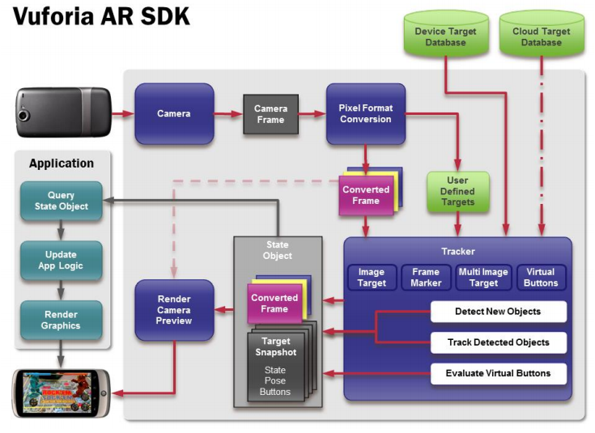

Figure 2.8 Model of AR application developed by Vuforia SDK

(Source:*https://developer.vuforia.com/sites/default/files/dev_guide_images/getting_started_SDK_devguide/vuforia_data_flow_diagram.png)*

2.2.4. *About Vuforia*

Vuforia platform is one of the most AR framework application and the best tool of image recognition. Vuforia supplies interesting features in multiple platforms such as iOS, Android and Unity 3D for developers to build native application.

2.3. Conclusion

The content that group presents in Chapter 2 shows the overview augmented reality and its application. Then, we introduce about Vuforia framework as well as its contribution in AR application development to figure out the reason which we choose the technology to do our thesis.

# Chapter 3

**System architecture and**

**Technical solution in backend development**

*✍ Content of chapter 3 presents general architecture of the system and the technology which group uses to implement back end component.*

## 3.1. Solution architecture

**3.1.1. *2-tiers architecture and 3-tiers architecture***

***3.1.1.1. Limitation of 2-tiers architecture***

2-tiers architecture is typical client-server system that server runs a DBMS for storing and retrieving physical data and optionally business execution (store procedure); and client is fat client. The client is responsible for connecting to server to exchange data, applying business rules, managing transactions, presenting data to the users and collecting input from users, resolving concurrent access problem,…

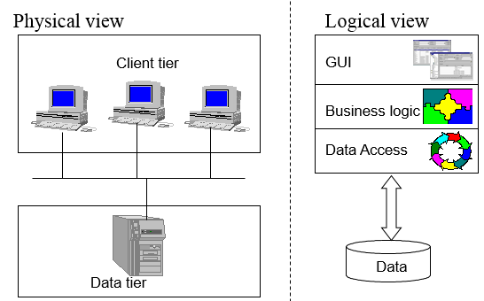

**Figure 3.1 Physical and logical view of 2-tiers architecture**

**(Source: ELCA Ltd training document)**

As the figure above, in 2-tiers architecture, client and server interact directly to each other. This has the some advantages as well as disadvantages points.

**Advantages**

Application can be easily to develop. Database server and business logic is physically closed, which make higher performance.

**Disadvantages**

The 2-tier model is lack of scalability because it only support a limited number of users. Moreover, server must process a large request centrally.

***3.1.1.2. Advantages and disadvantages of 3-tiers architecture***

To overcome with the disadvantages of 2-tiers architecture, the model of 3-tiers architecture are born. Data tier are the same; however, it has an application server (business tier) that implements and applies all business rules. Client tier are the same, but it does not connect to Data tier directly. Instead of doing this, client send request to business tier. Sometimes, the server load balance are available for process a large number of requests.

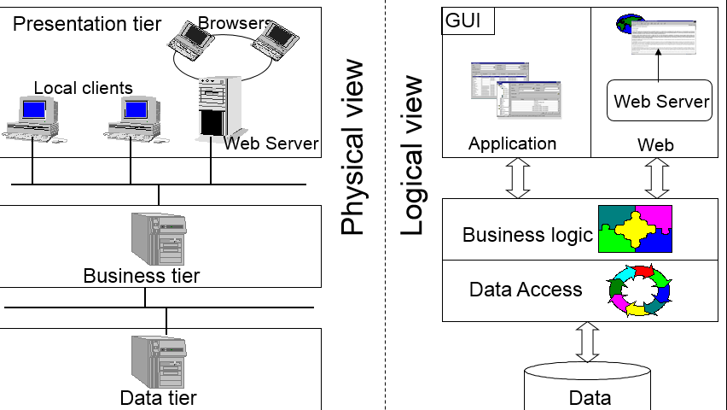

**Figure 3.2 Physical and logical view of 3-tiers architecture**

**(Source: ELCA Ltd training document)**

The **advantages** of this model is the ability to reuse code, effective running application. Moreover, the scalability (load balancing, connection pooling…) is also the most important factor that we must concern. For the view of developers, the model allows to separate clearly modules. This makes us easily to maintain and upgrade.

However, 3-tiers architecture still has some **disadvantages** such as: more infrastructure work and complex architecture. It takes more time and budget for implementation.

**3.1.2. *Application of 3-tiers architecture in the system***

***3.1.2.1. Why we use 3-tiers architecture***

By the time after researching augmented reality and its application, mobile market, ways of promotion, group decide to choose 3-tiers architecture for the system because:

* We think that the system is interesting. If it is widely applied, 3-tiers architecture is suitable because of the scalability.
* Many modules in the system are implemented concurrently, so division into small parts make us easily to fix, repair or update in the future.

***3.1.2.2. Architecture***

Based on 3-tiers architecture, we design the system as the Figure 3.3 below. In each tiers (physical view)), there are one or many layers to perform suitable functions.

**Common**

**WEB & APPLICATION**

**PRESENTATION TIER**

**SERVICES**

**DAO**

**BUSINESS TIER**



**DATA TIER**

**Figure 3.3 Application of 3-tiers architecture in the system**

The **data tier** contains 1.mdf file (extension of MS SQL Server database file) and its backup files, log files.

The **business tier** contains 2 layers:

* Data access layers (DAO) plays only 1 primary roles: access directly to database (supported by ORM framework – NHibernate) to perform CRUD operations.
* Service layers provides interfaces to clients meaning web application (manager module) and mobile application (presenter module) for accessing to data in defined ways that are defined. All business logic, exception handling, and concurrent update handling are processed in the layers and serializable to other layers.

The **presentation tier** is the diverse definitions. In generic term, it contains 2 primary terms: web application (manager module) and mobile application (presenter module). To explain exactly the meaning of presentation tier, we set it comprising all mobiles devices which use the presenter module application and all devices that use the manager module web.

**Common** section defines a lot of classes, helpers, extension methods that are used in many different ways. For examples:

* Dto: The NHibernate mapping (ORM definition) classes that map with tables in database design.
* JsonHelpers: A class contains methods for parsing classes to JSON and vice versa as well as parsing XML to JSON and vice versa.
* ExtensionMethod: Brings the Append() method of StringBuilder to String (C#)
* Services interface: Interface for clients to call services API.

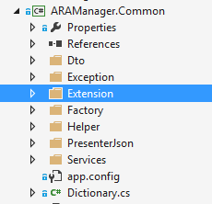

**Figure 3.4 Common module in solution**

***3.1.2.3. Implementation***

Every components in the system is transparent, this means it can just see its dimension as:

* Clients can just see Presentation (Client services factory – a class for getting services)
* Presentation can just see Services
* Services can just see Data access

All of them has one general point is that one common module. Figure 3.5 describe how the architecture of the system except presenter module and data tier.

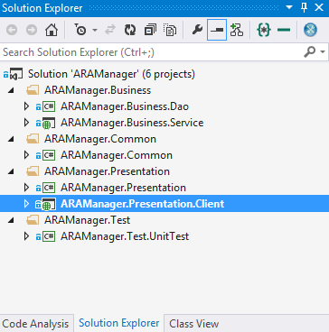

**Figure 3.5 Solutions structure of manager module and services**

## 3.2. Services layer

### 3.2.1. *Problem*

Develop web service system to help query data operation, information are concerned from both Modules: Manager and Presenter in an efficient way.

### 3.2.2. *Solution -WCF*

Group proposes to build a system providing Web Service API supplying functions to query based on RESTful architecture.

***What is RESTful?***

REST is given to apply a constructive way and simple web service perform operation of main complex concept of traditional Web Services.

REST stands for Representational State Transfer - in the sense of allowing users to access resources - resource (is data before and after handling or functionalities of the applications) – Web services application through URL.

Mechanisms between server and client is point to point.

The data is transmitted directly over HTTP and is accessed via HTTP under MIME format without SOAP format - reduce complexity - for simplicity, we shall consider data and functions as parameters or data transmission attached in HTTP

Allowing data manipulation under 4/7 method defined in HTTP as GET, POST, PUT, DELETE to clearly specify how to manipulate data on the server, what are accessed, what are edited, which are displayed and hidden ...

Requests when using REST:

* Client and Server: Client and Server must talk using the same interface and protocol
* Use the layers architecture and do not store status after the process is responded
* Cache Memory: the return value is stored in the client
* Code on Demand: clients obtain data in the returned value after processes in servers are completed.
* Uniform Interface: each client resource is accessed through unique address and use the defined method.

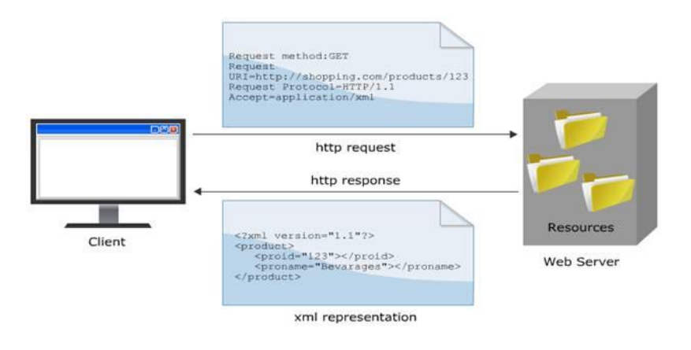

**Figure 3.6 The mechanism of RESTful.**

**(Source: http://kieutrongkhanh.net/index.php/java-web-service-x/79-gii-thiu-v-restful-web-services)**

***Why choose RESTful?***

Nowadays, in the world, there are two kinds of common architectures used to build a Web Service system are: RESTful and SOAP. Here would be the comparison between two buildings on.

We can perceive some benefit in using RESTful are:

* Do not depend on any intermediary system - as SOAP and WSDL do.
* The design using RESTful transmits data via protocol HTTP allows internal applications to use in an easy and powerful way: Asynchronous JavaScript + XML / JSON (Ajax).
* The strong combination of AJAX and RESTful also makes more developers to learn and use.

## 3.3. Data access layer

### 3.3.1. *Problem*

Build an ORM to map object model to database model for easily working.

### 3.3.2. *Solution – NHibernate framework*

Object-oriented and relational database may be cumbersome. NHibernate is an object/relational mapping tool for .NET environments. Object/relational mapping (ORM) refers to the technique of mapping a data representation from an object model to a relational data model.

NHibernate also help developers in:

* Data query and retrieval facilities in compare with manual data handling in SQL and ADO.NET
* Useful with object-oriented domain models and business logic
* Remove or encapsulate vendor-specific SQL code
* Help with the common task of result set translation from a tabular representation to a graph of objects.

## 3.4. Result

We successfully create NHibernate mapping between database schemas and object model, define services for both manager and presenter module. The data access project are built to handle transaction, concurrent update; exceptions are also serialize all solution.

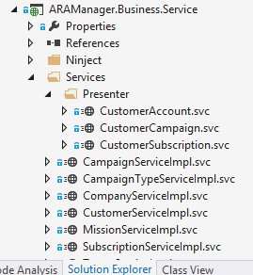

**Figure 3.7 Service project**

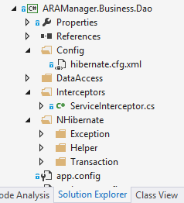

**Figure 3.8 Data Access project**

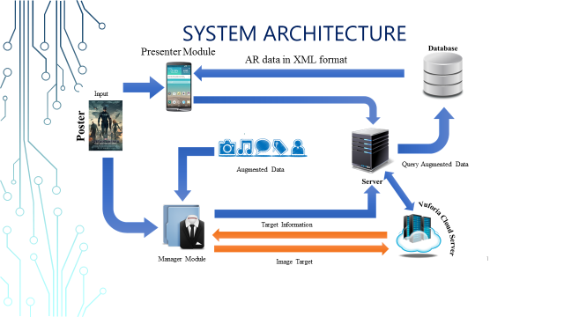

**Figure 3.9 System architecture**

# Chapter 4

**Some problems and**

**Technical solution in Management module development**

*✍ Content of chapter 4 presents some problems encountered in building management module, interface issues, and expressing information. In Chapter 4, group also presents the ASP.NET technology to the module.*

## 4.1. The objectives of the management module

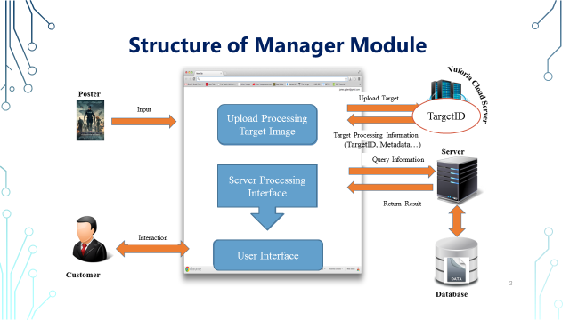

**Figure 4-1 Structure of manager module**

The module contains 2 types of users:

_ Admin: the module supports admin to manage customers and companies account as well as view statistics.

_ Company’ manager: Group builds the module to support in the design augmented information to perform show in presenter module. This module allows marketing managers to build advertising campaign with augmented information; do statistics, manage campaigns and users that have joined the campaign.

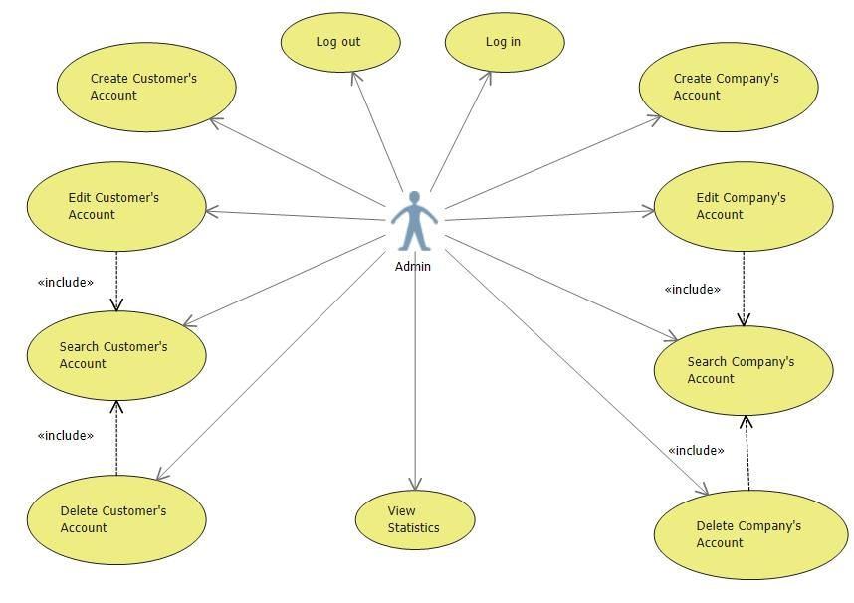

**Figure 4-2 Use case diagram of Admin**

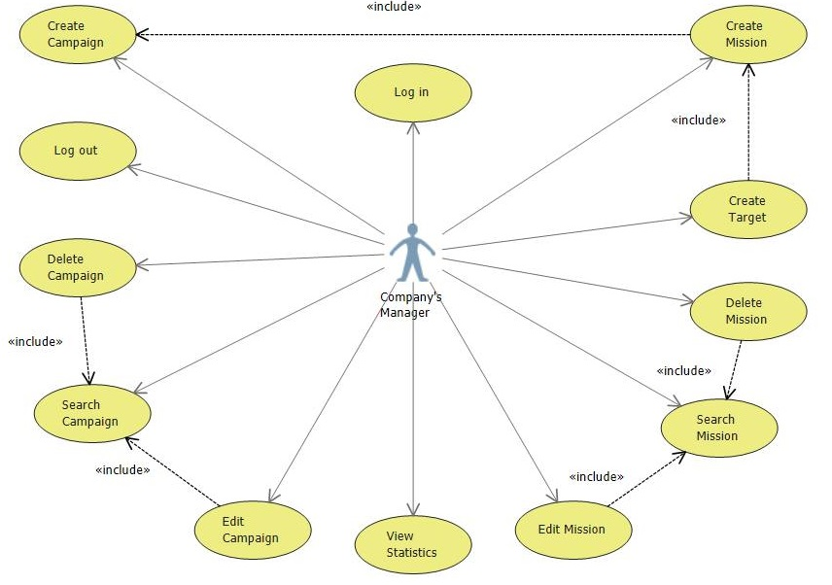

**Figure 4-3 Use case diagram of Company’ manager**

## 4.2. Processes of Admin’ functions

### 4.2.1. *Create, View, Edit, and Delete customer*

After login to system, Admin users can select section “Customer” to go to Customer manager page.

At this page, admin can search customer by UserName… Then the search result containing list of suitable customers are returned. Admin are able to edit, delete or update information of any customers by simple clicking on his or her id, the action navigates to edit page.

There is another functions is to create new customer account for Admin role. The function is built to face with the case that company directly to Admin instead of sending information of company through email.

### 4.2.2. *Create, View, Edit, and Delete company account*

After Admin receive information of company through email or direct request, he or she go to “Company” management page to company account.

Admin can also search company by UserName to view and/or edit information. He or she can delete the company account in system if there is any suitable reason such as: company leaves the system, company violates regulation, and company does not work at the moment…

### 4.2.3. *View statistic*

The statistic function let Admin follow the rate of customers by male and female, age. From the result, Admin recognize the development of system to make suitable business plan.

## 4.3. Processes of Company’ manager’ function

### 4.3.1. *Create, View, Edit, and Delete campaign*

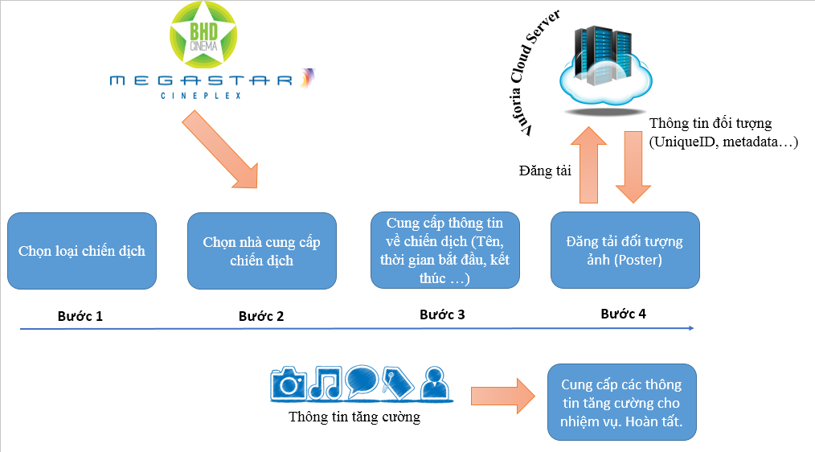

**Figure 4-4 Process of creating new campaign**

Adding a new campaign displayed on the interface of web browsers by 3 following steps:

* *Step 1*: Choose category for a new campaign: check in, tour and theater. Regarding this category of campaign, if the system is applied and implemented widely, we will have more extensive variety of different campaigns, not only encapsulated in 2 or 3 categories as test systems.

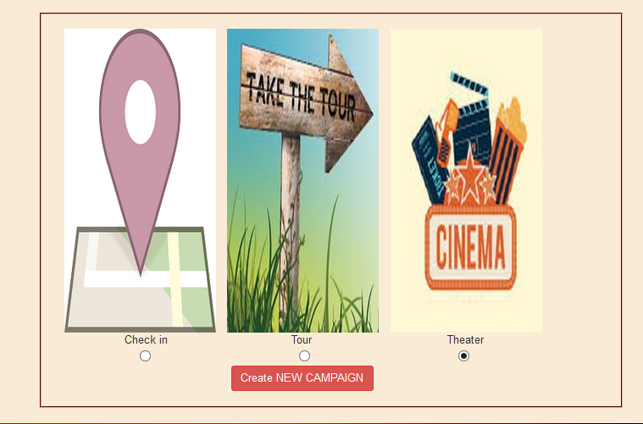

* *Step 2*: Provide information about the campaign. The required information of a campaign will be added here: campaign name, start date and time, end date and time, a brief description about the campaign. The number of tasks needed to be complete.

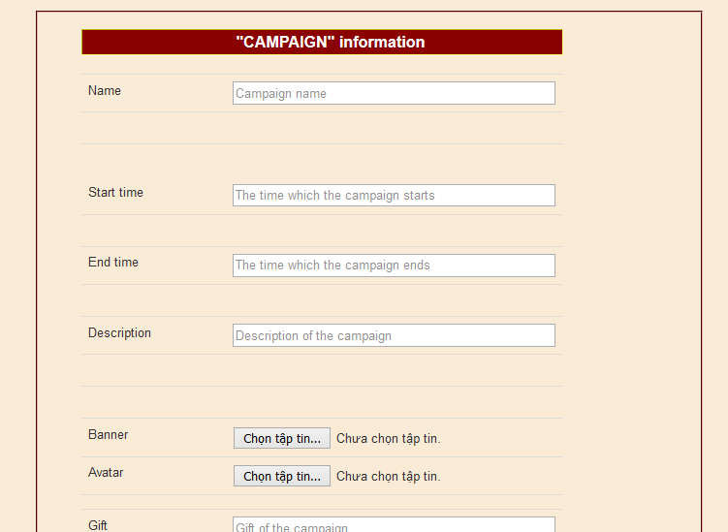

**Figure 4-5 Enter campaign information**

* *Step 3*: Provide information of missions. At this stage, the number of missions provided in Step 2 will be described clearly. For each mission, users need to upload pictures for using in each respective mission. At this step, website builds and supplies a particular site for users to upload pictures. Required information of images that will be posted are Link and Image Name (no space).

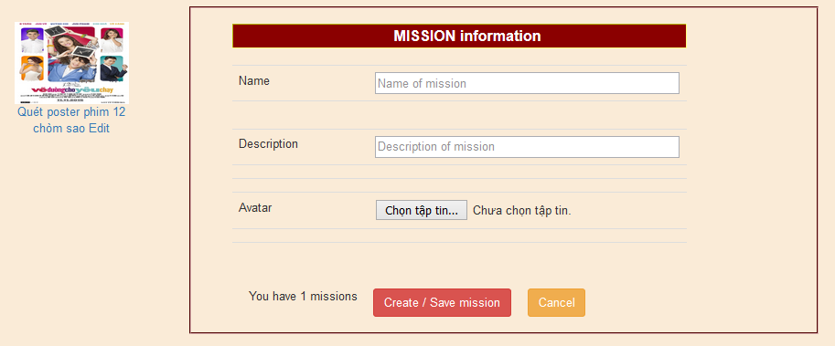

**Figure 4-6 Enter mission information**

* After the posting step completes, the image will be uploaded to the Cloud Server and analyzed. The process is long or fast depending on the size and complexity of color in photos. Target Id of each target is stored in database.
* In addition, since this is a campaign about the movie so the needed information providing for tasks are about movies information: movie name, actors, director, manufacturing year ...

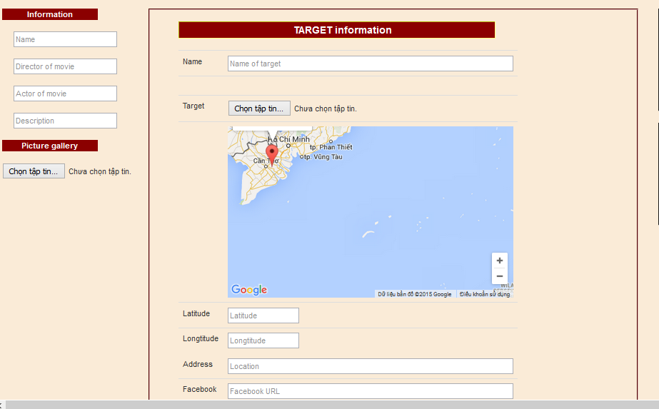

**Figure 4-7 Enter AR information used for uploading target, building AR data**

Since the image information processing on Cloud Server is invariant, no fixed time depending on image quality and complexity of images, to make sure about the time required for the program may start running, users should wait after 2-3 hours.

After completing 3 above steps and approximate 2-3 hours waiting for processing images on the Cloud Server, campaign design is complete and it can start working.

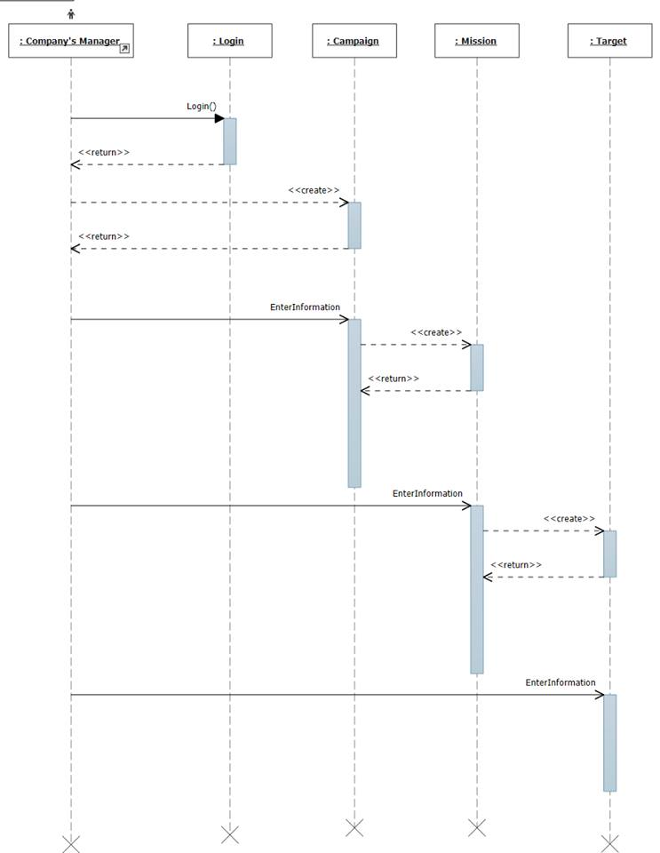

**Figure 4-8 Sequence diagram of creating new campaign**

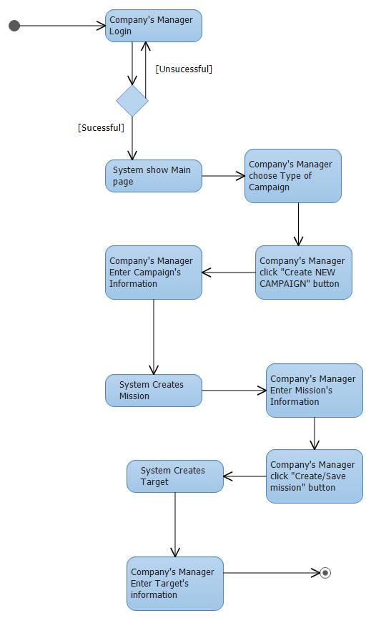

**Figure 4-9 Activity diagram of creating new campaign**

### 4.3.2. *View statistics*

The statistic function let Company’ manager track the rate of joining customer in each campaign to plan the new suitable strategy in the next campaign or stop inefficient campaign.

## 4.4. Solution

### 4.3.1. *Flow*

**Services**

**Client Service Factory**

**Clients**

**Data access**

**Figure 4-10 Process flow in manager module**

### 4.3.2. *Technologies*

#### *4.3.2.1. Show Map*

***Problem***

In manger module, group has built functional map to guide users the direction and location to complete mission.

***Solution***

To draw the map up on the web, group uses Subgurim Map – the most advanced Google Map API for ASP.NET. The control brings the full power of the official Google Map API v3 without JavaScript code in .NET. Another advantage point of Subgurim is that we do not need to register with Google, Subgurim do it for us.

***Result***

By applying Subgurim Map control, group builds the function that show map in target information page. When company’ managers create targets, they can point to the location of the target that satisfy their mission’ demand.

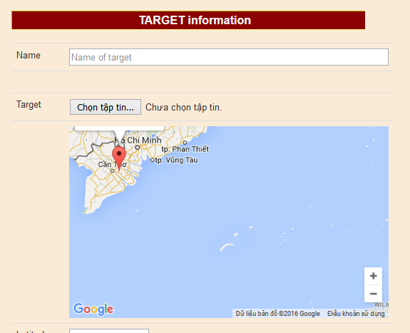

**Figure 4-11 The Map built by Subgurim control**

#### *4.3.2.2. Show statistics charts*

***Problem***

In each campaign, company’ manager wants to summarize, review that rate of joined customers in the program. Admin also needs to check the rate of members in system by age or sex.

***Solution***

In the manager module, group builds statistical chart serving the marketing managers. To have the exact statistical and intuitive numbers, group` has studied and used chart of AJAX control toolkit.

AJAX control toolkit may not be a perfect way to display data on the web page with diverse types of chart: area chart, bar chart, pie chart, line chart, bubble chart; however, in the demand of the system, we think that it provide us enough functions.

***Result***

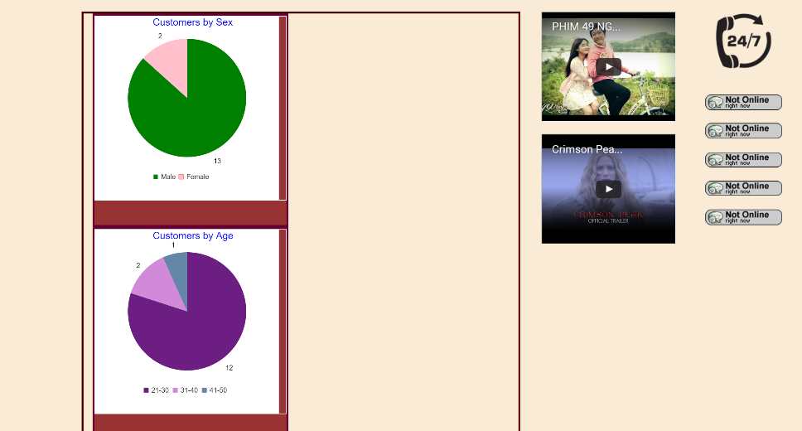

**Figure 4-12 The Statistics chart show the percentage of customers by age and sex.**

#### *4.3.2.3. Bootstrap*

***Problem***

By the development of mobile devices that group introduces in 1.1.2, the rate of customers ***using mobiles*** to accessing manager module is ***very*** ***large***. This requires the website has mobile interface.

***Solution***

Bootstrap is a collection of CSS and JavaScript that strongly supports design layout of a web-based interface. Bootstrap supports many Web browsers on computers as well as mobile devices. Today, there are millions of websites being designed thanks to this framework. By more than 200 icons and hundreds of professional effects, Bootstrap can help us to quickly have the most delicate site layout in a simple way.

#### *4.3.2.4. Vuforia*

***Problem***

Company’ manager needs a tool to recognize their posters and show augmented data to customers.

***Solution***

Vuforia section supports customer to upload target to Vuforia Cloud Server for presenter module. The main features of the section is to upload, edit, delete target.

**Using Vuforia API**

To use API of Vuforia, developers need to register account at website <https://developer.vuforia.com/>. Login with the recent register account, select Target Manager > Cloud Database > Create Database (Figure 4.7). Enter name of database then click Create.

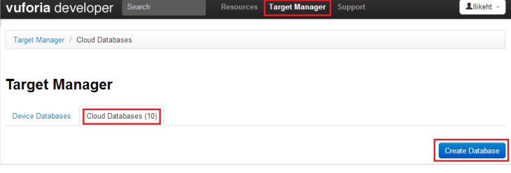

**Figure 4-13 Create Vuforia Cloud Database**

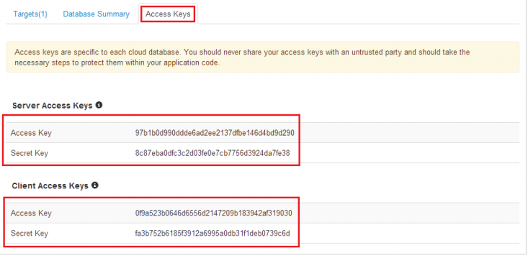

**Figure 4-14 Pairs of keys in Vuforia**

Each database is created with a pair of server access key and server secret key. API of Vuforia can just be used to add, delete, edit, and get information of target of particular database. Therefore, if developers want to create different databases, the only way is to use GUI web. To get a pair of keys of database, click on the database > Access Keys. The pair of server access keys is used by API for add, updating, delete target. The pair of client access keys is used in presenter module to recognize target and get Meta associated with the target.

**Authentication of Vuforia**

Vuforia does not used Oauth method to authenticate. Each API request has to add Authorization environment to header. The header has form:

C:\Users\Phuc\Desktop\Untitled.png

Signature is built:

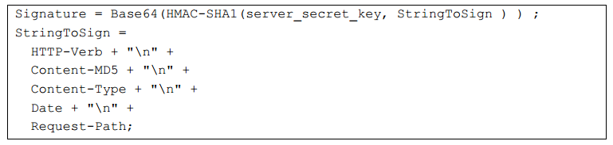

Notes:

HTTP-Verb: GET/POST/PUT

Content-MD5: hash value MD5 of body, if HTTP verb is GET (no body), the value is d41d8cd98f00b204e9800998ecf8427e.

Content-Type: multipart/form-data. If request has no body, content type is empty string.

Date: the created date of request attached in each header of request.

Request-Path: API path of each API, example: /target, /summary

API of Vuforia has header in form:

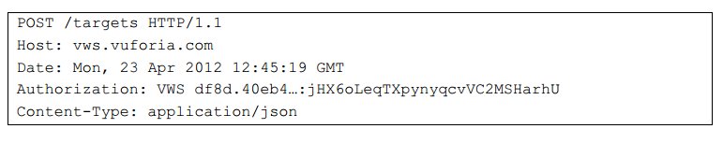

**Add new target**

**Request**:

POST – <https://vws.vuforia.com/targets>

Body of request contains the following fields

|  |  |  |
| --- | --- | --- |
| **Fields** | **Mandatory** | **Meanings** |
| name | yes | name of target |
| width | yes | width of target image |
| image |  | content of image encoded base64 (jpg and png format, maximum size is 2.25 MB) |
| active_flag |  | target is active or disable. |
| application_metadata |  | meta encoded base64 (maximum size is 150 KB) |

**Table 4-1 Fields in request body to create, update target.**

* image can be replaced by image_url, but not both at the same time.

**Respone**:

If everything success, service returns response in json format with the following fields

|  |  |
| --- | --- |
| **Fields** | **Meanings** |
| result_code | status: TargetCreated |
| transaction_id | id of transaction |
| target_id | id of target in database (used for updating, deleting the target) |

**Table 4-2 Return result of creation new target API.**

**Update target**

**Request:**

Similar to add new target but using the following address:

PUT – <https://vws.vuforia.com/targets/:targetid>

**Delete target**

**Request:**

DELETE – <https://vws.vuforia.com/targets/:targetid>

**Response**:

Similar to response of adding new target.

## 4.5. Result

Manager module has a nice user interface and easy to use. The service is currently deployed on Somee hosting - best free powerful hosting for ASP.NET website. Here are some pictures of the module.

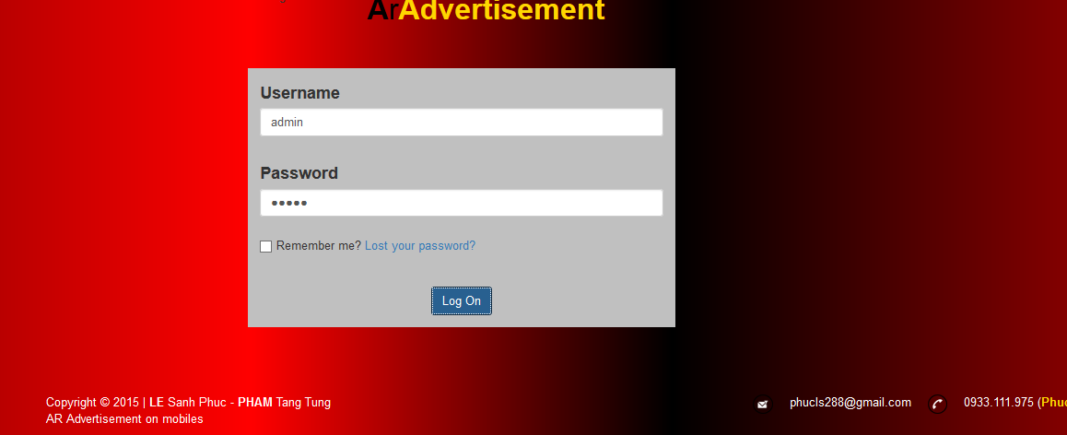

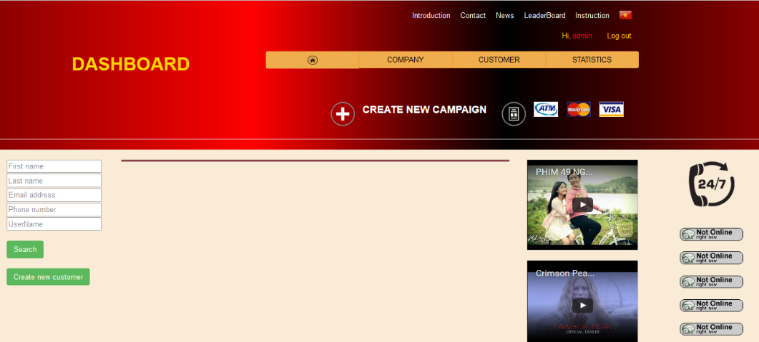

**Figure 4-15 Some pictures in manager module**

## 4.6. Conclusion

Manager module focuses on designing eye-catching interface, simple to use, providing marketing managers an easy working environment. It does not require high information technology knowledge to use the management website; users easily create advertising campaigns using augmented reality.

By using ASP.NET architecture, the website is designed in the way that is very compact lightweight, easy to grow in the future. The user interface of the site can be customized quickly, suitable for trend and demand of users without attention about the process of logic in the system due to the support of model.

# Chapter 6

**Summary**

*✍ In the chapter, we summarize the achieved result of group on Manager and Presenter modules. The contents of this chapter also mention about the the future development of the system.*

## 6.1. Results

Objectives set out in this research is to propose solutions to practical application in enhancing in the advertising process improvements, and enhanced interoperability between users and managers marketing strategies. First, the solution in question Export provides managers design tools and operational information increases intensity for each product needs marketing, advertising, and helps them these statistics Sticky figures on the level of user attention to the campaign, the so that they can grasp the needs and tastes of users and continues to set the promotional marketing strategies more effective. Next there is provision for User information enhancing diversity-related resources increased intensity for product images on the media (banner, poster, logo ....), including multi-media information (images, video, audio, text ...) as well as social media information (opinion of commentators, the forum discussion, videos, documents related with the Internet). In addition, the solution also enhance the interoperability of the user through operation appealing, attract more users to experience the new product advertised like the love, share on social networking sites like Facebook contributing popular products widely promoted to numerous users. The system will provide users with an approach completely new products, interesting; making receiving the advertising information comfortable, convenient and attractive.

The proposed solution consists of two main components: (1) site facilities management helpful, quick to build Marketing managers, design information and increased activity corresponding to the products with ease, as well as create bridges between advertisers and users to the advertising services reached maximum efficiency; (2) system image recognition processing and presentation of information increases corresponding intensity on mobile devices using Vuforia SDK. Mobile Devices at This is like a prism intelligent, allowing users to have more strengthen the necessary information to help them answer the questions, concerns While the selection of new products, and provide users with the latest promotion information with simple operations.

During the discovery process, to implement the project we were using the content basically, most of Vuforia necessary to build the system. These contents have presented in the previous chapters of the thesis. With the fast development pace fast processing of algorithms and hardware improvements, in the near future surely the reality enhancement will apply robust, widely in many fields of life in which the advertising sector will thrive.

On the architecture of the system, the group we have applied the knowledge learned applied to design the system architecture scalable later, can add more module, new resources into the system.

In the topic, we were using the library's Vuforia Qualcomm to get object types and performances. During the discovery process, we were aware of how the operation of libraries and have the change to serve the system works his performance. We also understand how to use the APIs provided by Vuforia order to generate data for the system through the management module. In the topic, we do not study or improvement of image recognition algorithms Image. The image recognition is done through Vuforia SDK. Besides that group also presented some key business processes using the system presented in Chapter 5.

3 Group has built a campaign form, 3 types of tasks. Deploy test 8 campaign experience, 27 different missions.

3 form the campaign was based on the following scenarios: •

Learn the product: The manager will develop a campaign to encourage customers learn about their products. The campaign asks customers learn about one or a series of company products, then customers will get the promotion of the program. Depending on the requirements of regulators reasons, the customer will use the app to take pictures of products, learn the enhanced information at any place or even mandatory to companies, The Company’s showroom.

Examples: Cinema BHD will present four new films a week and love customer demand to join the campaign to find out all the information of 4 sets Film, customers will receive a 10% discount when participating fare program. One in four films are films of the week the focus will require customers must photograph poster product at the theater system BHD.

**Figure 6-1 Campaign products**

Tour: This is the form of encouraging users to visit and find out enough locations or important information of a certain location. Participants will be guided on a tour app to learn places and shooting guide that points to more hip about location visit and complete the campaign. Points will be accumulated follow everywhere he goes through and perform tasks.

For example, the IT Faculty of the University of Natural Sciences organized tour, learn about science for freshmen and high school students are intending to scientific examination. The pupils and students the application to to school, go to the department office, room departments. Photograph panel room name and learn the information to strengthen prevention that subject. If explore every room of scientific disciplines, students will be awarded an anniversary gift.

**Figure 6-2 Campaign visit**

This scenario would be appropriate for the campaign as at: fairs (Visit the booth where organizers wish), companies (tour departments), schools (ministries and departments), resort or resort entertainment. Construction form this campaign could develop for users (customers) to follow a route built.

Check in: users, customers simply place your place to belonging to a store or a chain of system to accumulate points. Point will vary depending on the situation: if customers frequently point to an area savings will be increased even more if only occasionally had or points will be High savings if the user has more than one store in a system shop - will receive a gift if it meets the administration fixed point reasonable offer. This scenario aimed to encourage users to interest and loyalty to their products.

Example: A sports training center want their customers to maintain participated in regular exercise center, customer wants to mount with center. They will use this campaign to customers in central check in mind when returning to practice, the customers come back often Trans will enjoy the center's preferential more.

**Figure 5-3 Campaign Check in**

This scenario is consistent with a store or a chain of stores one system: cafes, cinemas. Some of the results achieved on the management module: •

Module is built on ASP.net platform, using programming technology MVC should guarantee the security aspects, the exchange of information.

The program interface easy to use with components that are logically organized, simply gives the user the convenience of the user.

Supporting several information resources to strengthen multi-media format, Social Media, and interactive activities. It is through this interaction activities system contributes to the group's tighter bridge between managers and user. Everything is done right on the mobile device. Especially the resource information and activities can enhance a dynamic supplement easily later. •

Management functions and statistics help users to manage work easily. Through this function, the manager can grasp promptly breaking and tastes of users to build ad campaigns Brand better governance.

The statistical functions with intuitive charts, vivid help for people manage easily grasp the effectiveness of the program correctly, comprehensive.

Supporting the format of interactive activities for construction management campaigns to attract and interesting.

Functions Integrated customer lists to campaign helps managers capture information of potential customers.

Some results achieved in the demonstration module:

For users who use android device to scan objects product image Is to the information strengthened.

Users can interact with the objects increase the information, with Activities form the object. Users can join the action exciting promotions, comments, questions and answers about products, share information, good quality products for relatives and friends.

Besides the construction of two main modules as management module and the module Forum, the group has built a system that provides the API necessary for in data communication between the database and the two modules. The output of the function API is the resource as JSON, ease of transmission and distribution utility resource.

## 6.2. Development

Using enhanced reality technologies with interactive way intelligent, users will have a very interesting experience, improve quality information and attracting the attention of users. Within the scope of the subject, we aim to understand and develop a solution testing real direction in enhancing service advertising sector theatrical movie titles. This is one of the first steps for the group going into research, analyze and reality application development strengthened in practice used to improve operations advertising today, far more will be many aspects of society, such as reading books, games play, inform, educate ...

Specifically on the subject, the group would give some direction developed as follows:

* Redesigned interface modules both more professional, suit each content of different products. Because Thread serve advertising sector should Interface design must be eye-catching and attract the attention of photosynthesis viewers. For each specific product types should have the corresponding interfaces with the trends and tastes of the user.
* Improve the transfer speeds between databases and the modules. Developing more the image processing to not depend on Vuforia. Processing speed of system heavily dependent on system speed data transmission, thus to strengthen More information for users who need to have a system fast enough, part hardware devices should be upgraded to improve performance of system use President. Also, the development of a particular image processing module to not must depend on Vuforia.

For the development of management modules:

* Supporting resource model uses three-dimensional technology and other game specific resources, specific to each product.
* Supports for new users to define a resource of information, increased activity.
* Support multiple different modules of specialized products.

For the development of demonstration modules:

* Supporting resource screened three-dimensional model.
* Optimizing the performances / shows the object information strengthened. Show this information is used to strengthen widgets provided by Android. To increase the professional and nice to have the presentation / express new. • Support for many more interactive activities, bringing new, unique, fun location for advertising. Currently the system only provides two active trials interactive advertising campaigns. The development of operations attract new interactive user needs to have the expertise of developers marketing.
* Assist in identifying sound, enhanced information displays when users read keywords or product names. Identification sound instead of scanning Product images will make the system a reality strengthening development new, more exciting, allowing users to have a completely new experience leaves.
* Develop the system on iOS devices, Windows Phone will help us System users have access to a larger volume, richer. If only collection General in a particular operating system, we will lose a number of people great use in other operating systems.

# REFERENCES

[1] R. T. Azuma, "A Survey of Augmented Reality," Malibu, 1995.

[2] genk, "Augmented Reality – Chân trời mới của thế giới công nghệ không còn quá xa vời," genk.vn, 30 june 2012. [Online]. Available: http://genk.vn/pc-do-choi-so/augmented-reality-chan-troi-moi-cua-the-gioi-cong-nghe-khong-con-qua-xa-voi-2012062912589808.chn.

[3] AF-STUDIO, Super Monitoring, "Infographic: 2013 Mobile Growth Statistic," Digitalbuzzblog, 1 10 2013. [Online]. Available: http://www.digitalbuzzblog.com/infographic-2013-mobile-growth-statistics/.

[4] NguyenMauTam, "Quảng Cáo là gì ?," Vnecon.vn, 8 4 2008. [Online]. Available: http://www.vnecon.vn/threads/quang-cao-la-gi.1122/.

[5] Infonet, "Thời của quảng cáo trên thiết bị di động lên ngôi," Vietnamnet, 2 7 2014. [Online]. Available: <http://vietnamnet.vn/vn/cong-nghe-thong-tin-vien-thong/183865/thoi-cua-quang-cao-tren-thiet-bi-di-dong-len-ngoi.html>.

[6] AF-STUDIO, Super Monitoring, "Infographic: 2013 Mobile Growth Statistic," Digitalbuzzblog, 1 10 2013. [Online]. Available: http://www.digitalbuzzblog.com/infographic-2013-mobile-growth-statistics/.

[7] "Tối ưu hóa chiến dịch khuyến mại của doanh nghiệp," Báo doanh nhân sài gòn điện tử, 02 08 2010. [Online]

[8] B. Insider, "11 Amazing Augmented Reality Ads," Business Insider, 28 1 2012. [Online]. Available: http://www.businessinsider.com/11-amazing-augmented-reality-ads-2012-1#net-a-porter-makes-storefronts-interactive-1.